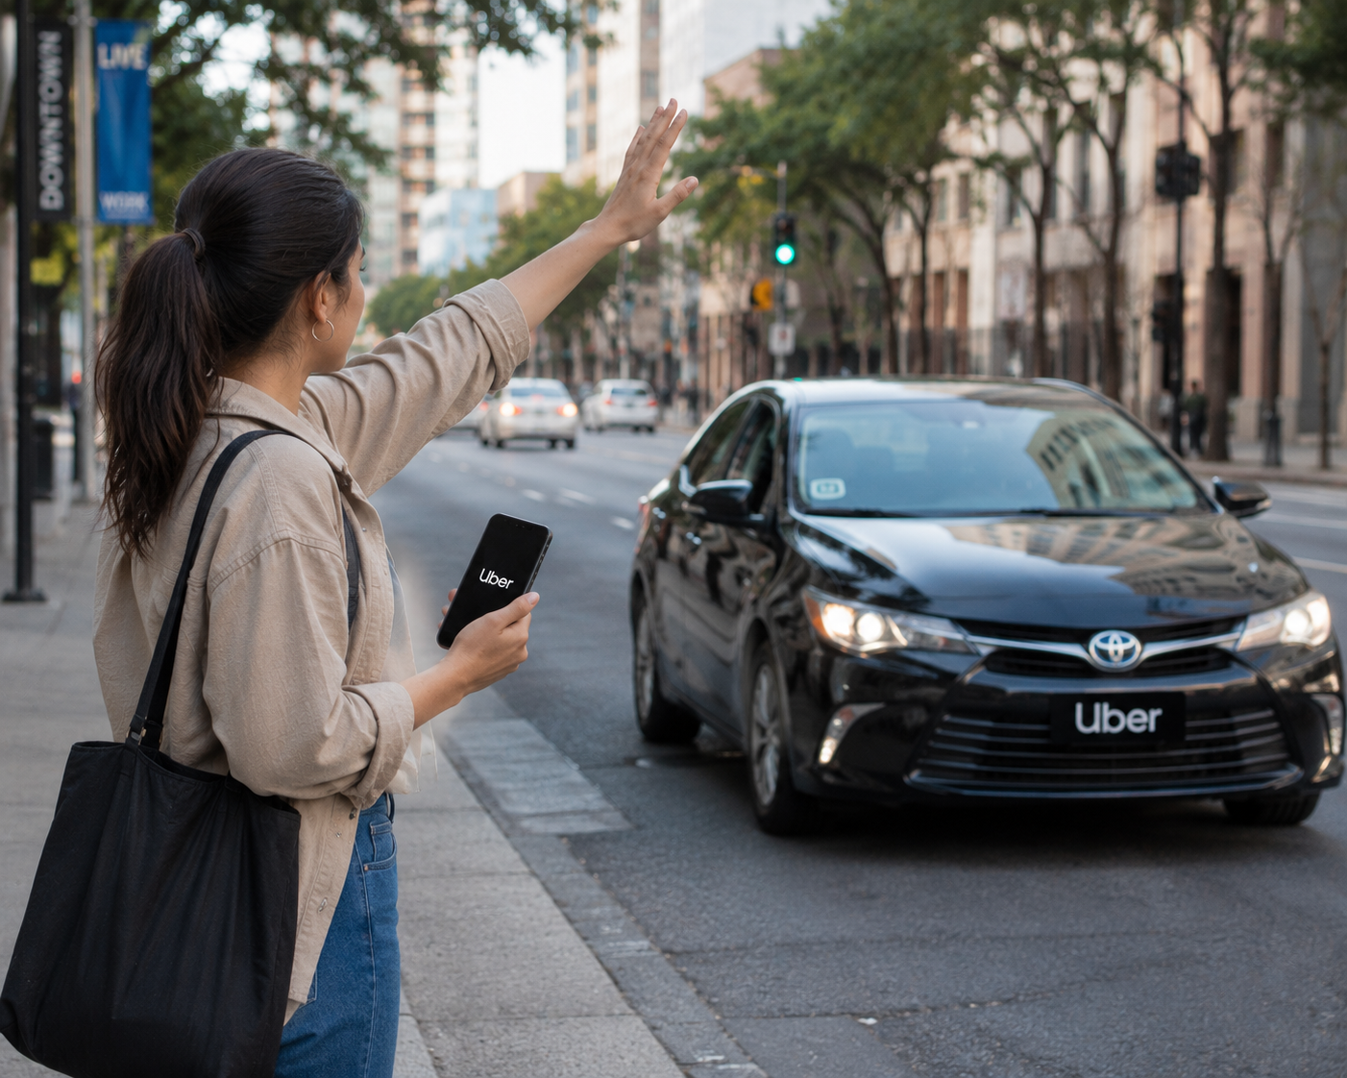  Analysis of the Types of People Who Use Uber | Abstract

Analysis of the Types of People Who Use Uber and the Possible Dangers for Uber Drivers

1. Introduction
Uber is a global ride-hailing platform that connects passengers and drivers through a mobile application. Since its launch in 2009, Uber has significantly changed the way people travel in cities across the world. Instead of relying only on traditional taxis or public transport, users can now request a ride instantly using a smartphone. This technological innovation has made transport more convenient, accessible, and efficient.
Millions of people use Uber daily for different purposes. Some rely on it for daily commuting, while others use it occasionally for special events or emergencies. Because Uber serves such a wide range of customers, drivers interact with many different types of passengers. Each group has unique behaviours, expectations, and potential risks.
Understanding the types of people who use Uber is important for analysing both the benefits and dangers of the service. While Uber creates flexible income opportunities for drivers, it also exposes them to various physical, emotional, financial, and digital risks. This analysis explores the main categories of Uber users and discusses the possible dangers drivers may face while operating on the platform.

2. Students and Young Adults
Students and young adults form one of the largest groups of Uber users. Many students do not own vehicles and depend on ride-hailing services for transport to school, university, shopping centres, sports activities, and social events. Uber is popular among this group because it is easy to use and often more affordable than traditional taxi services.
Young adults frequently request rides during evenings and weekends. After concerts, parties, or other entertainment events, Uber provides a safer alternative to driving under the influence of alcohol. However, this also introduces certain risks for drivers. Intoxicated passengers may behave unpredictably, speak loudly, damage the vehicle, or even become aggressive.
Drivers may also experience cleaning issues if passengers become sick inside the vehicle. Although Uber provides compensation policies in some cases, dealing with such incidents can be stressful and time-consuming. Drivers must remain calm, patient, and professional when transporting young passengers, especially late at night.

3. Working Professionals
Working professionals represent another important category of Uber users. These individuals use Uber for daily commuting, airport transfers, business meetings, and corporate events. They usually value punctuality, safety, and comfort. Many professionals choose premium options such as UberBlack for a higher-quality experience.
Compared to nightlife passengers, professionals are generally lower-risk in terms of behaviour. However, drivers may face pressure to arrive quickly, especially during peak traffic hours. Passengers running late for meetings or flights may become impatient or stressed.
Time pressure can lead to risky driving behaviours if drivers attempt to speed or take unsafe shortcuts. Maintaining safe driving practices is essential even when passengers are in a hurry. Traffic congestion during peak hours also increases accident risk and driver fatigue.

4. Tourists and Visitors
Tourists often rely on Uber when visiting unfamiliar cities. They may not understand local transport systems, language, or currency. Uber’s GPS tracking, digital payment system, and clear fare estimates provide reassurance and convenience.
Tourists may ask drivers for recommendations about attractions, restaurants, and safety tips. In some cases, drivers become informal ambassadors for their city. While this interaction can be negative, misunderstandings may arise due to language barriers.
Drivers may also face safety concerns if tourists carry visible luggage or expensive items, which could attract criminal attention. In high-risk areas, stopping to load luggage may increase vulnerability. Drivers must remain aware of their surroundings and choose safe pickup and drop-off points.

5. Families and Elderly Passengers
Families and elderly passengers use Uber for medical appointments, shopping, family gatherings, and daily errands. These passengers may require additional assistance, such as help with luggage, mobility aids, or child seats.
While this group is generally respectful and low-risk in terms of criminal behaviour, physical demands may increase for drivers. Helping passengers in and out of vehicles can cause strain or delays.
Drivers must ensure compliance with safety regulations, especially regarding child car seats. Failure to follow safety laws could result in fines or legal consequences. Patience and attentiveness are important when transporting elderly or vulnerable passengers.

6. Nightlife and Entertainment Users
Passengers travelling to or from bars, clubs, and entertainment venues present higher safety risks. These rides often occur late at night when crime rates and alcohol consumption are higher.
Drivers may encounter aggressive behaviour, arguments between passengers, refusal to pay cleaning fees, or vandalism. Late-night driving also increases the likelihood of robbery, especially in poorly lit or isolated areas.
Fatigue is another major risk. Drivers who work long hours or overnight shifts may experience reduced alertness and slower reaction times. Fatigue contributes significantly to road accidents. Proper rest and responsible scheduling are essential to reduce these dangers.

7. High-Risk or Criminal Intent Users
Although most passengers use Uber responsibly, a small minority may attempt criminal activity. Drivers work alone and may be vulnerable to robbery or assault, particularly in areas with high crime rates.
Criminals may request rides to isolated locations or attempt to steal the driver’s phone or vehicle. In rare cases, drivers have been threatened or attacked.
Uber has introduced safety features such as real-time GPS tracking, emergency assistance buttons, and ride-sharing details with trusted contacts. However, drivers must remain vigilant, avoid suspicious trips, and trust their instincts if a situation feels unsafe.

8. Emotional or Distressed Passengers
Some passengers may be emotionally distressed due to personal issues, medical emergencies, or conflict. Drivers may transport individuals who are crying, anxious, or visibly upset.
While many of these situations are harmless, emotional distress can sometimes escalate into unpredictable behaviour. Drivers are not trained counsellors and must maintain professional boundaries.
If a passenger appears unstable or threatening, the driver should stop in a safe public location and contact emergency services if necessary. Personal safety must always come first.

9. Road-Related Dangers
Apart from passenger-related risks, Uber drivers face everyday road dangers. These include reckless drivers, poor weather conditions, potholes, vehicle breakdowns, and traffic congestion.
Regular vehicle maintenance is crucial. Faulty brakes, worn tyres, or engine problems increase accident risk. Defensive driving and adherence to traffic laws are key safety practices.
Long working hours increase fatigue and decrease concentration. Driving while tired is comparable to driving under the influence of alcohol in terms of reduced reaction time.

10. Digital and Financial Risks
Uber drivers also face digital and financial challenges. App glitches, incorrect GPS navigation, or payment disputes can cause frustration and income loss.
False passenger complaints may result in temporary account suspension. Since drivers rely on the platform for income, such suspensions can have serious financial consequences.
Cybersecurity threats are also a concern. Drivers must protect login details and avoid phishing scams. Additionally, rising fuel costs and vehicle maintenance expenses affect overall profitability.

11. Preventative Safety Measures
Drivers can reduce risk by following strict safety procedures. These include verifying passenger names before starting trips, avoiding cash transactions where possible, and sharing trip details with trusted contacts.
Installing dashboard cameras provides evidence in case of disputes. Choosing well-lit pickup points and avoiding isolated areas improves safety.
Drivers should schedule regular rest breaks and avoid working excessive hours. Maintaining insurance coverage and staying updated on local regulations also provides protection.

12. Conclusion
Uber serves a diverse group of passengers, including students, professionals, tourists, families, and nightlife users. Each group presents different behaviours and potential risks.
While Uber offers flexibility and income opportunities, drivers must navigate safety, financial, and digital challenges. By understanding the types of passengers and possible dangers, drivers can adopt preventative strategies to protect themselves.

